**Assignment for Linux skills**

1. Create a new directory called "practice" in your home directory.

Command: mkdir ~/practice

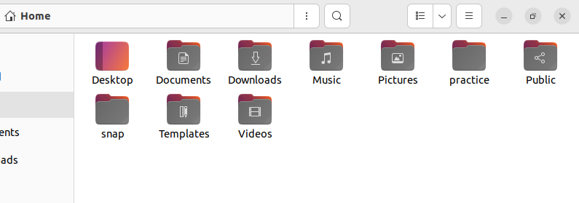

1. Inside the "practice" directory, create a new file called "file1.txt" and add some text to it.

Command: pluma file1.text

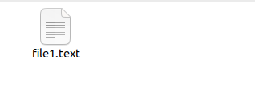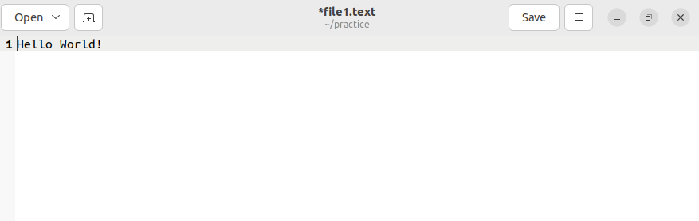

1. Copy "file1.txt" to a new file called "file2.txt" in the same directory.

Command: cp file1.text file2.text

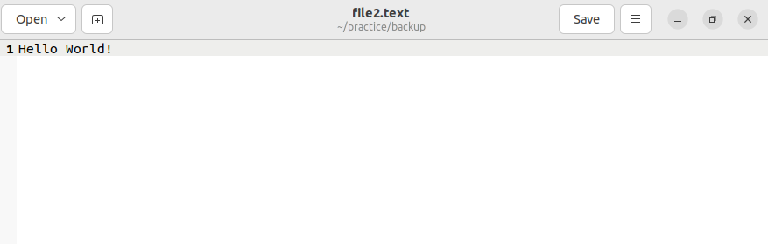

1. Move "file2.txt" to a new directory called "backup" that is located inside the "practice" directory.

Command: pluma file2.text

mkdir backup

mv file2.text backup

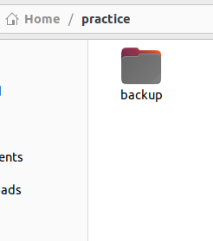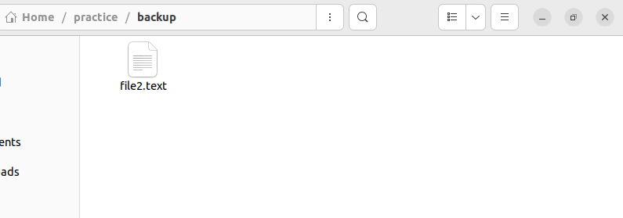

5.Create a new directory called "scripts" inside the "practice" directory.

Command: mkdir ~/practice/scripts

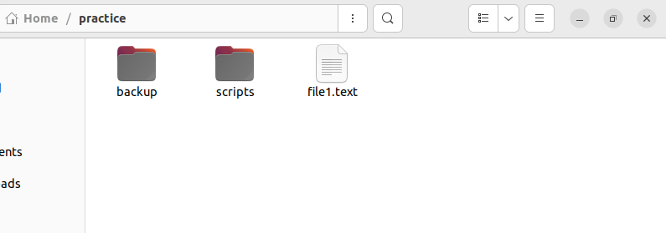

6.Create a new file called "myscript.sh" inside the "scripts" directory.

Command: touch ~/practice/scripts/myscript.sh

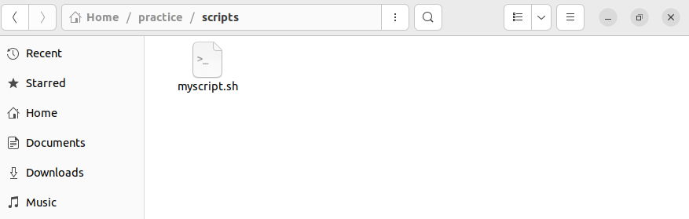

7. Add the following code to "myscript.sh":

#!/bin/bash

Command: nano myscript.sh

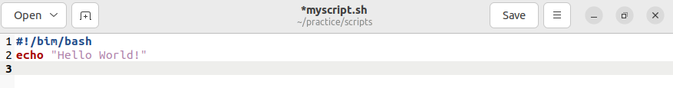

8. echo "Hello World!".

9. Make "myscript.sh" executable using the command "chmod +x myscript.sh".

Command: chmod +x myscript.sh

10. Run "myscript.sh" using the command "./myscript.sh".

Command: ./myscript.sh

11.Add a line to "myscript.sh" that creates a new file called "output.txt" in the same directory and writes the output of the "echo" command to it.

12.Run "myscript.sh" again and verify that "output.txt" has been created and contains the expected output.

13.Create a new user account called "testuser".

14.Switch to the "test user" account using the command "su testuser".

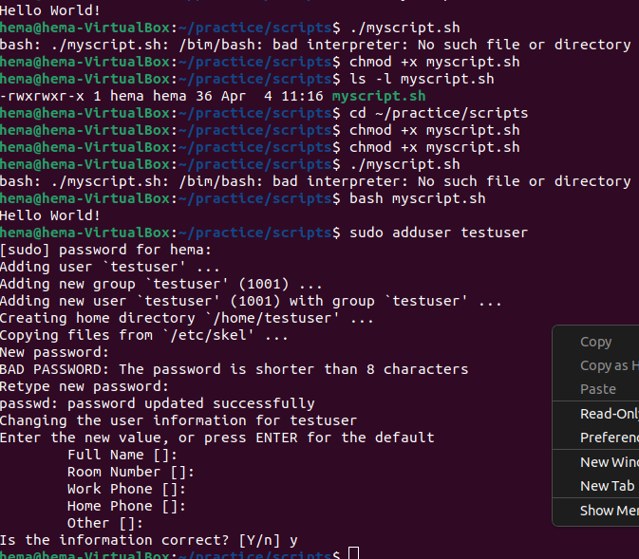15. Verify that you are now logged in as "testuser" using the command "whoami".

Command: whoami

Output:hema